## Maharashtra Academy of Engineering & Educational Research’s MIT POLYTECHNIC, PUNE



**MICRO PROJECT REPORT**

### Academic year: 2022-23

**Topic:- Attendance Management Project**

### Program: Information Technology Program code: IF3I

**Course: Object Oriented Programming Course code: 22316**

**Using C++**

**GUIDED BY**

( **Prof. P. U. Nehete**)

**Maharashtra Academy of Engineering & Educational Research’s MIT POLYTECHNIC, PUNE**

## Maharashtra Academy of Engineering & Educational Research’s MIT POLYTECHNIC, PUNE

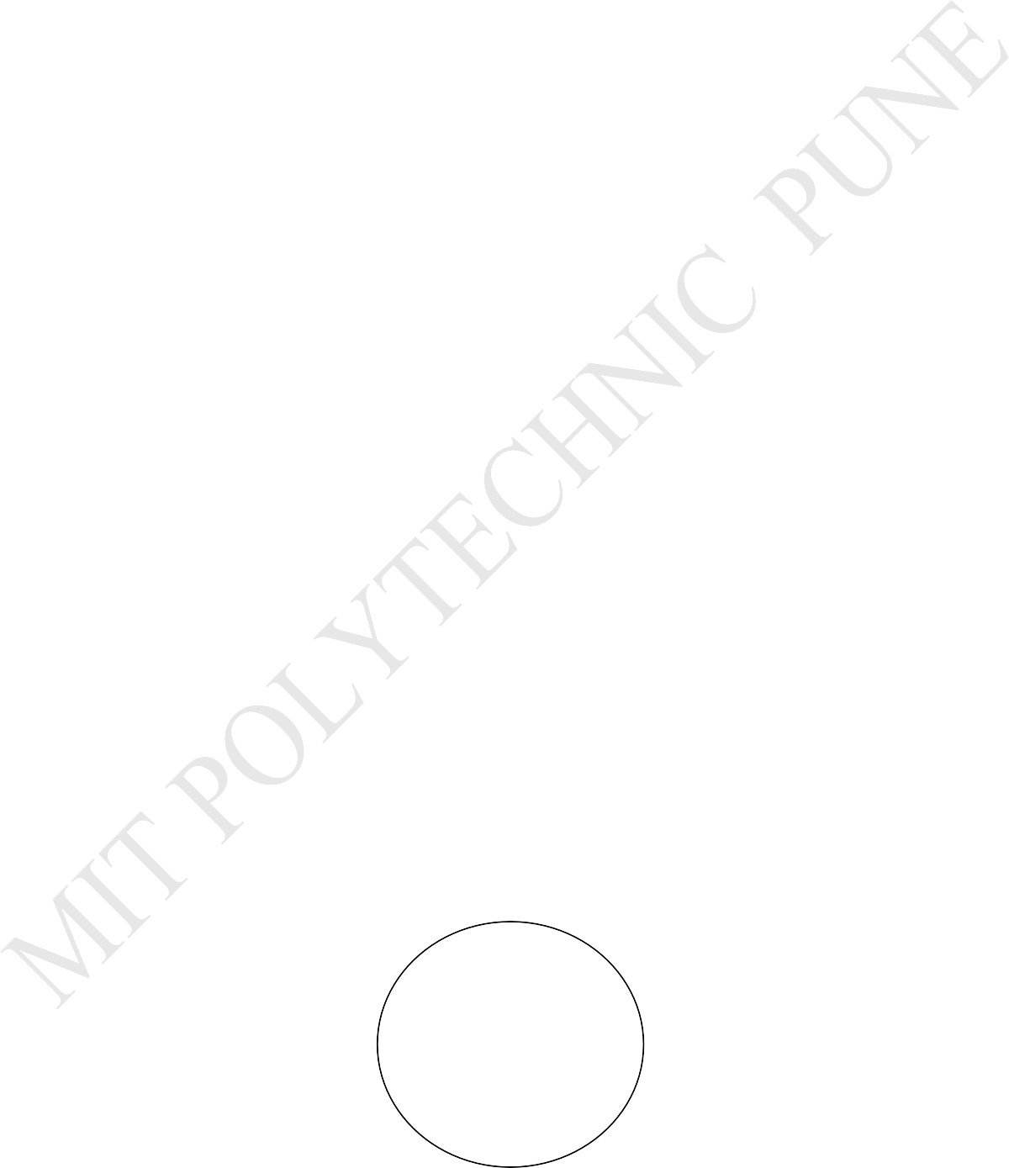

**Certificate**

This is to certify that Mr. **Gaurav Balasaheb Mali,** Roll No. **12** of the 3rd semester of Diploma in **Information Technology** of Institute **MIT POLYTECHNIC, Pune** has completed the **Micro Project Report** satisfactorily in **Course: Object Oriented Programming Using C++** for the academic year **2022- 2023** as prescribed in the curriculum.

### Place: Pune Enrolment No: 2101480048

**Date:** 10/05/2022 **Exam. Seat No: 170040**

|  |  |  |
| --- | --- | --- |
| **Prof. P. U. Nehete** | **Prof. M. P. Fatangare** | **Dr. R. S. Kale** |
| Subject teacher | Head of the Department | Principal |

Institute seal

**MIT POLYTECHNIC, PUNE**

## Maharashtra Academy of Engineering & Educational Research’s MIT POLYTECHNIC, PUNE



**Certificate**

This is to certify that Mr. **Jaydeep Sunil Kulkarni,** Roll No. **02** of the 3rd semester of Diploma in **Information Technology** of Institute **MIT POLYTECHNIC, Pune** has completed the **Micro Project Report** satisfactorily in **Course: Object Oriented Programming Using C++** for the academic year **2022- 2023** as prescribed in the curriculum.

### Place: Pune Enrolment No: 2101480037

**Date:** 10/05/2022 **Exam. Seat No: 170030**

|  |  |  |
| --- | --- | --- |
| **Prof. P. U. Nehete** | **Prof. M. P. Fatangare** | **Dr. R. S. Kale** |
| Subject teacher | Head of the Department | Principal |

Institute seal

**MIT POLYTECHNIC, PUNE**



## Maharashtra Academy of Engineering & Educational Research’s MIT POLYTECHNIC, PUNE



**Certificate**

This is to certify that Mr. **Sarth Suhas Sheth** Roll No. **05** of the 3rd semester of Diploma in **Information Technology** of Institute **MIT POLYTECHNIC, Pune** has completed the **Micro Project Report** satisfactorily in **Course: Object Oriented Programming Using C++** for the academic year **2022- 2023** as prescribed in the curriculum.

### Place: Pune Enrolment No: 2101480040

**Date:** 10/05/2022 **Exam. Seat No: 170033**

|  |  |  |
| --- | --- | --- |
| **Prof. P. U. Nehete** | **Prof. M. P. Fatangare** | **Dr. R. S. Kale** |
| Subject teacher | Head of the Department | Principal |
|  |  |  |

Institute seal

**MIT POLYTECHNIC, PUNE**



## Maharashtra Academy of Engineering & Educational Research’s MIT POLYTECHNIC, PUNE



**Certificate**

This is to certify that Mr.**Tanishq Tanaji Vhanmane,** Roll No. **25** of the 3rd semester of Diploma in **Information Technology** of Institute **MIT POLYTECHNIC, Pune** has completed the **Micro Project Report** satisfactorily in **Course: Object Oriented Programming Using C++** for the academic year **2022- 2023** as prescribed in the curriculum.

### Place: Pune Enrolment No: 2101480062

**Date:** 10/05/2022 **Exam. Seat No: 170053**

|  |  |  |
| --- | --- | --- |
| **Prof. P. U. Nehete** | **Prof. M. P. Fatangare** | **Dr. R. S. Kale** |
| Subject teacher | Head of the Department | Principal |

Institute seal

**MIT POLYTECHNIC, PUNE**

**Maharashtra State Board of Technical Education**

Student/Group details:

|  |  |  |  |  |
| --- | --- | --- | --- | --- |
| Sr.  No. | Name of Group Members/student | Roll no. | Enrolment no. | Seat no. |
| 1 | Jaydeep Kulkarni | 02 | 2101480037 | 1770030 |
| 2 | Gaurav Mali | 12 | 2101480048 | 1770040 |
| 3 | Sarth Sheth | 05 | 2101480051 | 1770033 |
| 4 | Tanishq Vhanmane | 25 | 2101480071 | 1770053 |

Name of Guide:

**Prof. P. U. Nehete**

**INDEX**

|  |  |
| --- | --- |
| **SR.**  **NO.** | **CONTENT** |
| **1** | **Attendance Management Project** |
| **2** | **Attendance Management Project Code** |
| **3** | **Attendance Management Project Output** |
| **4** | **Introduction** |
| **5** | **Literature Review** |
| **6** | **Annexure** |
| **7** | **Micro-Project Evaluation Sheet** |

**ACTION PLAN**

|  |  |  |  |
| --- | --- | --- | --- |
| **Sr. No** | **Details of activity** | **Planned**  **Start date** | **Planned Finish date** |
|  | Discussion and finalization of the topic. | 07/12/2022 | 07/12/2022 |
|  | Collection of Data from the website | 07/12/2022 | 07/12/2022 |
|  | Collection of Data from the book | 07/12/2022 | 07/12/2022 |
|  | Organize all the contents/organizing material required | 07/12/2022 | 07/12/2022 |
|  | Assembling of the model (if any) | 07/12/2022 | 07/12/2022 |
|  | Final submission of Micro Project& report. | 07/12/2022 | 07/12/2022 |

Attendance Management Project

**Concepts Used in Project :**

* **Multilevel Inheritance**

**Multilevel Inheritance**

**When a base class is derived by a child class which is further derived by another child class, then it is known as multilevel inheritance.**

**The syntax: of multilevel inheritance is given below:**

**class base_class_name**

**{**

**properties;**

**methods;**

**};**

**class intermediate_class_name:visibility_mode base_class_name**

**{**

**properties;**

**methods;**

**};**

**class child_class_name:visibility_mode intermediate_class_name**

**{**

**properties;**

**methods;**

**};**

**The class which provides a link between two classes is known as an intermediate base class.**

**Code :**

**#include<iostream>**

**using namespace std;**

**char choice1;**

**char choice2;**

**char choice3;**

**char choice4;**

**char choice5;**

**char choice6;**

**char choice7;**

**char choice8;**

**char choice9;**

**char choice10;**

**char choice11;**

**char choice12;**

**class Date**

**{**

**public:**

**char date[30];**

**void date_d()**

**{**

**cout <<"\nEnter Date :";**

**cin.ignore();**

**cin.getline(date, 30);**

**}**

**void disp_date()**

**{**

**cout<<"\n\n\n\n------------------------------------------------------------";**

**cout <<"\nDate :"<<date;**

**cout<<"\n\n------------------------------------------------------------";**

**}**

**};**

**class Piyush: public Date**

**{**

**public:**

**void piyush()**

**{**

**cout <<"\n\n\nName = Piyush Yawatkar";**

**cout <<"\nRoll No = 1";**

**cout <<"\nEnter present or absent :";**

**cin >>choice1;**

**}**

**void disp_piyush()**

**{**

**switch(choice1)**

**{**

**case 'p':**

**cout <<"\nPiyush Yavatkar = Present";**

**break;**

**case 'a' :**

**cout <<"\nPiyush Yavatkar = Absent";**

**break;**

**}**

**}**

**};**

**class Jaydeep : public Piyush**

**{**

**public:**

**void jaydeep()**

**{**

**cout <<"\n\nName = Jaydeep Kulkarni";**

**cout <<"\nRoll No = 2";**

**cout <<"\nEnter present or absent :";**

**cin >>choice2;**

**}**

**void disp_jaydeep()**

**{**

**switch(choice2)**

**{**

**case 'p':**

**cout <<"\nJaydeep Kulkarni = Present";**

**break;**

**case 'a' :**

**cout <<"\nJaydeep Kulkarni = Absent";**

**break;**

**}**

**}**

**};**

**class Diksha : public Jaydeep**

**{**

**public:**

**void diksha()**

**{**

**cout <<"\n\nName = Diksha Jadhav";**

**cout <<"\nRoll no. = 3";**

**cout <<"\nEnter present or absent :";**

**cin >>choice3;**

**}**

**void disp_diksha()**

**{**

**switch(choice3)**

**{**

**case 'p':**

**cout <<"\nDiksha Jadhav = Present";**

**break;**

**case 'a' :**

**cout <<"\nDiksha Jadhav = Absent";**

**break;**

**}**

**}**

**};**

**class Avantika : public Diksha**

**{**

**public:**

**void avantika()**

**{**

**cout <<"\n\nName = Avantika Bhatgave";**

**cout <<"\nRoll no. = 4";**

**cout <<"\nEnter present or absent :";**

**cin >>choice4;**

**}**

**void disp_avantika()**

**{**

**switch(choice4)**

**{**

**case 'p':**

**cout <<"\nAvantika Bhatgave = Present";**

**break;**

**case 'a' :**

**cout <<"\nAvantika Bhatgave = Absent";**

**break;**

**}**

**}**

**};**

**class Sarth : public Avantika**

**{**

**public:**

**void sarth()**

**{**

**cout <<"\n\nName = Sarth Sheth";**

**cout <<"\nRoll no. = 5";**

**cout <<"\nEnter present or absent :";**

**cin >>choice5;**

**}**

**void disp_sarth()**

**{**

**switch(choice5)**

**{**

**case 'p':**

**cout <<"\nSarth Sheth = Present";**

**break;**

**case 'a' :**

**cout <<"\nSarth Sheth = Absent";**

**break;**

**}**

**}**

**};**

**class Nehete_maam : public Sarth**

**{**

**public:**

**void nehete_maam()**

**{**

**cout <<"\n\n\nName = Pallavi Nehete";**

**cout <<"\nTeacher ID = 10";**

**cout <<"\nEnter present or absent :";**

**cin >>choice11;**

**}**

**void disp_nehete()**

**{**

**switch(choice11)**

**{**

**case 'p':**

**cout <<"\nPallavi Nehete = Present";**

**break;**

**case 'a' :**

**cout <<"\nPallavi Nehete = Absent";**

**break;**

**}**

**}**

**};**

**class Fatangare_maam : public Nehete_maam**

**{**

**public:**

**void fatangare_maam()**

**{**

**cout <<"\n\nName = Mrunal Fatangare";**

**cout <<"\nTeacher ID = 12";**

**cout <<"\nEnter present or absent :";**

**cin >>choice12;**

**}**

**void disp_fatangare()**

**{**

**switch(choice12)**

**{**

**case 'p':**

**cout <<"\nMrunal Fatangare = Present";**

**break;**

**case 'a' :**

**cout <<"\nMrunal Fatangare = Absent";**

**break;**

**}**

**}**

**};**

**int main()**

**{**

**cout<<"\n\n\t\t\t\t\tWELCOME TO ATTENDANCE MANAGEMENT SYSTEM";**

**int pin;**

**while(1)**

**{**

**cout<<"\n\n\nEnter PIN :";**

**cin>>pin;**

**if(pin==1234)**

**{**

**while(1)**

**{**

**int choice;**

**cout<<"\n\n\n\n-------------------------------------------------------------------------";**

**cout <<"\n1. Student attendance";**

**cout <<"\n2. Staff Attendance ";**

**cout<<"\n3. Exit";**

**cout<<"\n-------------------------------------------------------------------------------";**

**cout <<"\n(Note - Enter 'a' for Absent and Enter 'p' for Present)";**

**cout<<"\n-------------------------------------------------------------------------------";**

**cout<<"\n\nEnter your choice :";**

**cin>>choice;**

**switch(choice)**

**{**

**case 1: cout<<"\n\n*** Take Student Attendacnce ****"<<endl;**

**Sarth d;**

**d.date_d();**

**d.piyush();**

**d.jaydeep();**

**d.diksha();**

**d.avantika();**

**d.sarth();**

**d.disp_date();**

**d.disp_piyush();**

**d.disp_jaydeep();**

**d.disp_diksha();**

**d.disp_avantika();**

**d.disp_sarth();**

**break;**

**case 2 : cout<<" \n\n**** Take Staff Attendance ****"<<endl;**

**Fatangare_maam f;**

**f.date_d();**

**f.nehete_maam();**

**f.fatangare_maam();**

**f.disp_date();**

**f.disp_nehete();**

**f.disp_fatangare();**

**break;**

**case 3 : exit(0);**

**break;**

**default : exit(0);**

**}**

**}**

**}**

**else**

**{**

**cout <<"\nWrong pin";**

**}**

**}**

**return 0;**

**}**

Output :

**Hello you very welcome to Attendance Management Project**

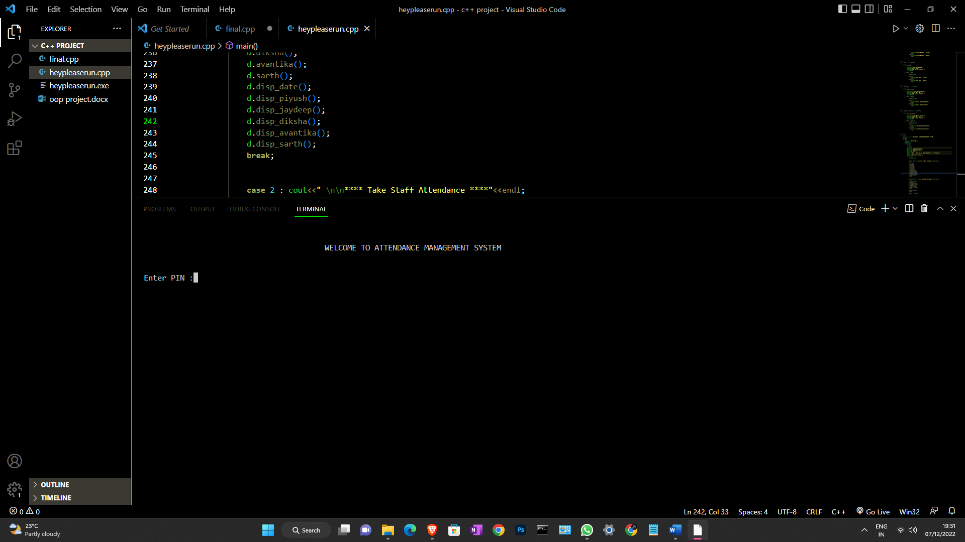

Enter pin as 1234 ( If you enter other pins it will get in the loop.)

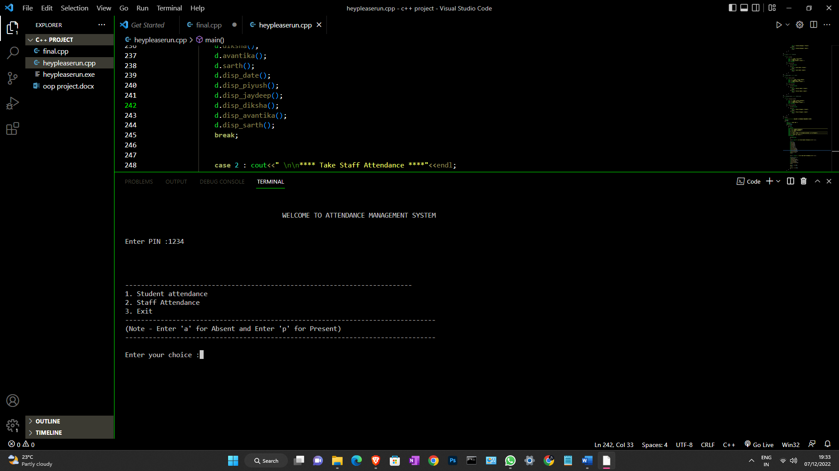

Hey Nice now you are welcome to take attendance, now just enter the

choice (1,2,3) .

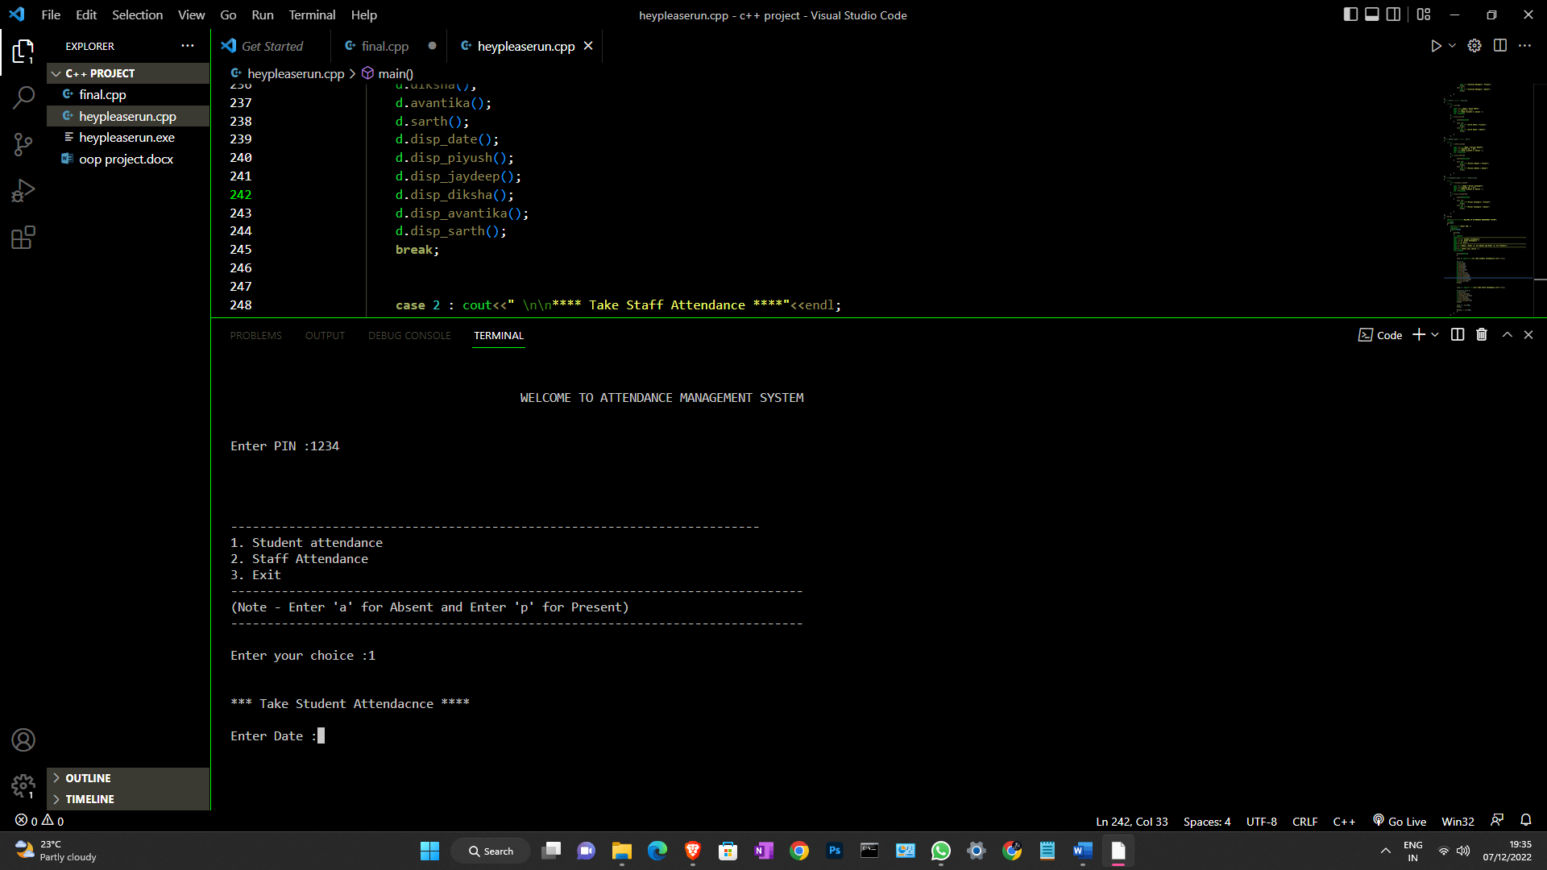

Now enter the date to get an accurate date of attendance. You can enter the date in any format like as below.

7.12.2022

7/12/2022

7 December 2022

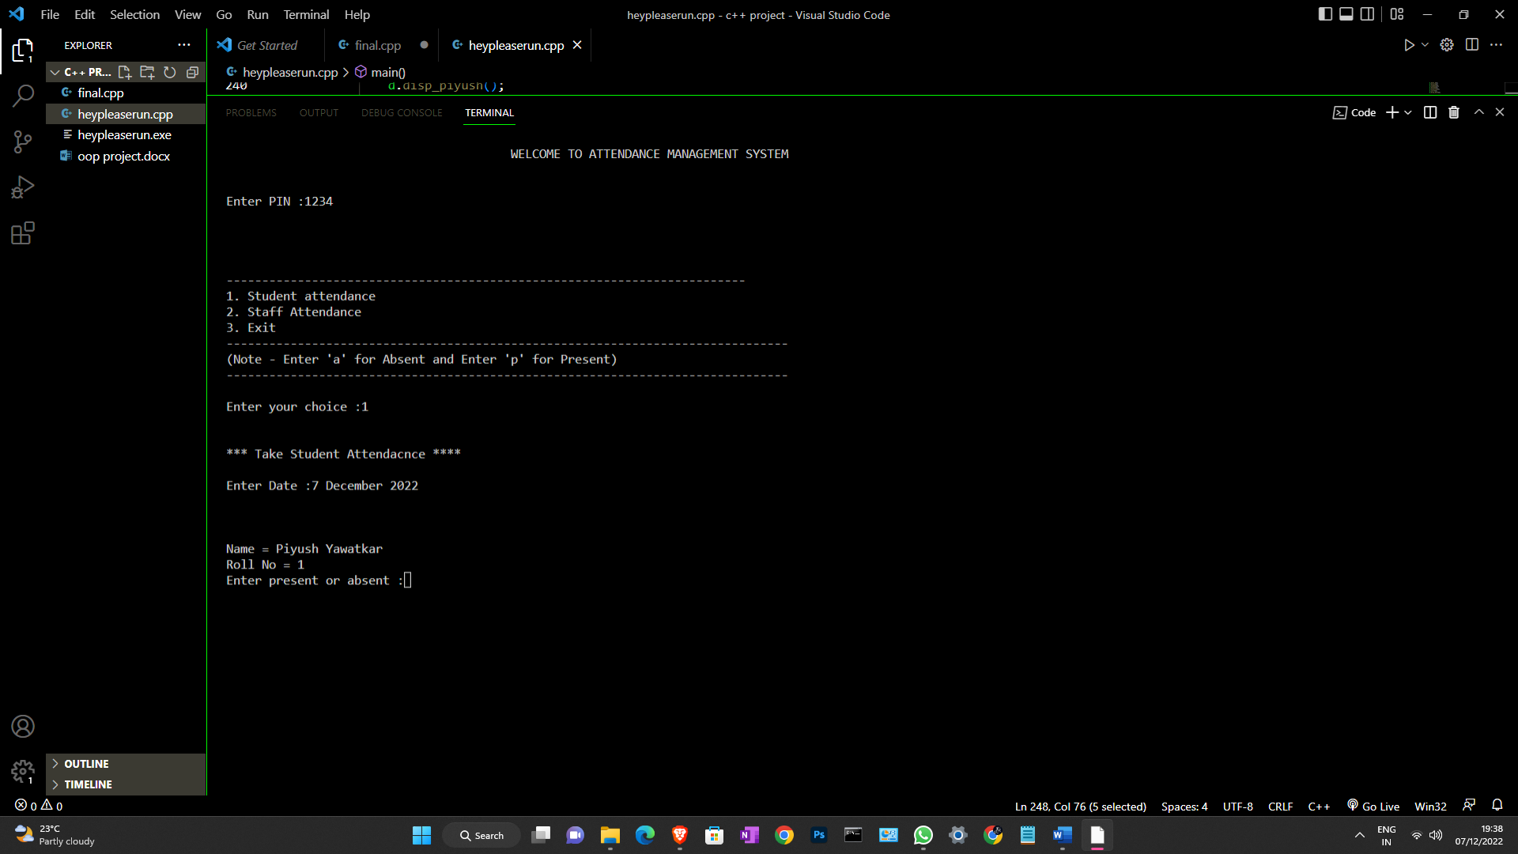

Hey, nice now you can take attendance finally, Okay so now you have to enter ‘a’ or ‘p’ for **a** is for **absent** and **p** is for the **present.**

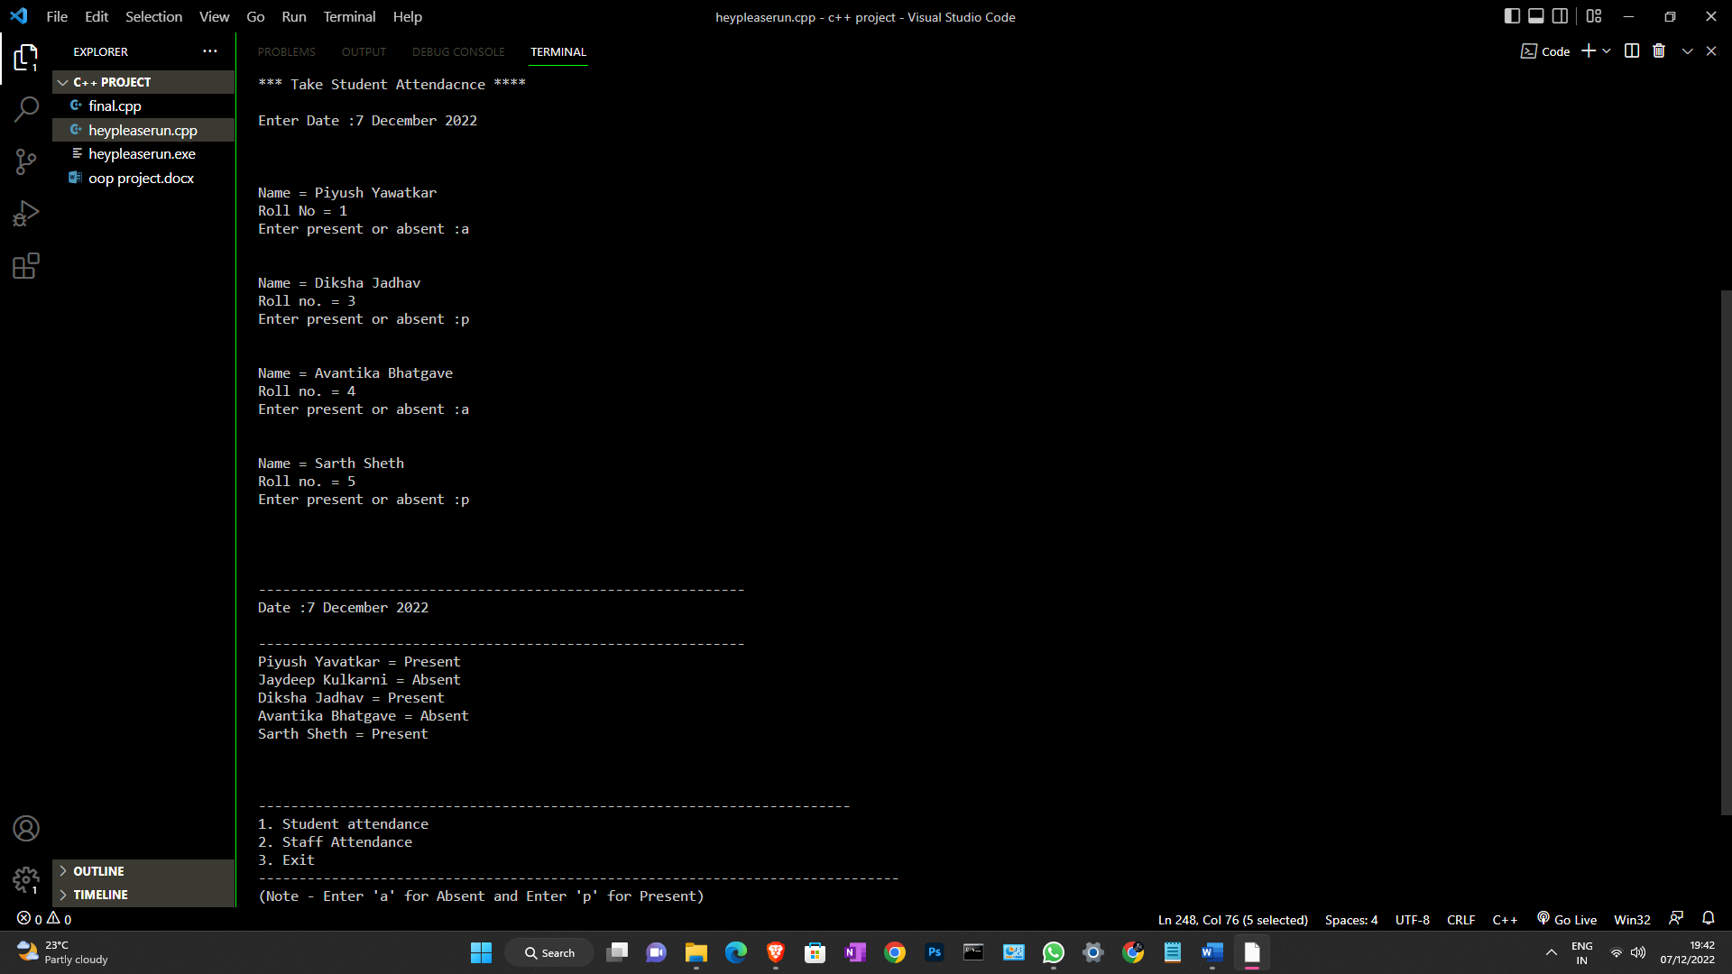

After taking all the attendance, you can also discover staff attendance. Okay now if you enter 3 in the choice then you get out from the code. And if you enter the choice for 2 then it will go for taking attendance for staff.

**1. Introduction**



The title of the micro-project is the Attendance Management Project.

In this project, we are going to show our created program using the c++ programming language.

So, here we try to take attendance of class using the program.

By getting the concept of multilevel inheritance

We are making try to take attendance of class freely by just entering a and p letters.

**2. Literature Review**

We see in this project how to make a program using the multilevel inheritance concept.

We have studied in detail to apply concepts in c++ programming.

We see how the outcome comes after compiling the code.

**Annexure-II A**

**PART B**

**To make a Website.**



## 1.0 Brief Description

* In this project, we are going to see Attendance Management System.
* I try to cover more details sub-concepts in this project like taking conditions with Multilevel Inheritance.
* Here we try to cover all conditions that apply in the multilevel inheritance concept.

## 2.0 Aim of Micro Project

* To Make **Attendance Management Project.**

**3.0 Proposed Methodology**

* We are doing this micro project in a Team of 4 members.
* We also took the guidance of the internet for more accurate information.
* We tried our full hundred percent to present the full fact and full knowledge.



## 4.0 Course Outcomes Integrated

* To know everybody how this small concept is also important in our daily life problems, while we can make the program to make load free.

**5.0 Details of Equipment**

* Computer system
* Software (MS. Office Word)
* Web Browser ( For compiling code )

# 6.0 Skills Developed from Micro Project

* From this Micro Project, we know how to apply conditions in Inheritance.
* To program freely in c++.
* Upgrade in logical level to thinking from all sides of the program, how can we execute the program best of the previous outcome.

**Micro-Project Evaluation Sheet**

|  |  |  |  |  |  |  |  |
| --- | --- | --- | --- | --- | --- | --- | --- |
| Roll no. | Student Name | Enrollment number | Process Assessment | | Product Assessment | | Total Mark s  (10) |
|  |  |  | Part A- Project Proposal  (2) | Project Methodology  (2) | Part B- Project report/ working model  (2) | Individual Present ation/V iva  (4) |  |
| 1 | Jaydeep Kulkarni | 2101480037 |  |  |  |  |  |
| 2 | Gaurav Mali | 2101480048 |  |  |  |  |  |
| 3 | Sarth Sheth | 2101480040 |  |  |  |  |  |
| 4 | Tanishq Vhanmane | 2101480062 |  |  |  |  |  |

Note: Every course teacher is expected to assign marks for group evolution in the first 3 columns and individual evaluation in the 4th column for each group of students as per rubrics.

### Comments/Suggestions about teamwork/leadership/ interpersonal communication (if any)

We acquire some more essential skills in simulation software.

### Any Other Comment:

I am thanking my friends and subject teacher for helping with this miraculous project.



**Name and designation of the Faculty Member**

**Prof. P. U. Nehete**

**Object Oriented Programming Using C++**

**Signature**